AI in Biotechnology (Aquaculture Technology)

AI( Artificial Intelligence INT-404)



Assigned by: - Pooja Rana(20992)

Submitted by:

Sakshi Jaiswal(12115331) – B31

Arushi Singh (12110716) – B20

Shubham Senapati (12110064) –A08

Table of Contents

1.Introduction3

1.1 Significance and scope of work4

1.2 Background Information4

1.3 Objectives……………………………………………………………………………….4

2.Noteworthy Contribution4

**3.Proposed Methodology………………………………………………………………….….7**

3.1Mobility model of surface floating node…………………………………………..8

**4. Mobility model of surface floating node………………………….....................................9**

4.1 Sensor System Design……………………………………………………………10

4.2 Cloud Architecture…………………………….…………………………………11

**5. Result Analysis……………………………………………………………………………12**

5.1 Aqua ward Application………………………………………………………….12

**6.Conclusion….…………….…………………………………………………….…………13**

**7.References…..…………………………………………………………………………….13**

**8.Appendix(code)…………..……………………………………………………………….14**

**9. Output…………………………………………………………………………………….15**

1.Introduction

Aquaculture is a fast-developing business that is critical to satisfying rising seafood demand, particularly in light of dwindling wild fish supplies. As the world's population continues to expand, demand for seafood is predicted to skyrocket in the next decades. The aquaculture business, on the other hand, has a number of obstacles, including disease outbreaks, water quality control, and feed supply.

Artificial intelligence (AI) is a technology that is increasingly being used to address these issues. AI is the application of computer algorithms to learn from data and make predictions or judgements based on that data. Farmers may use AI to monitor the health and activity of their fish populations in real time, forecast disease outbreaks, and improve feeding regimens by using AI to aquaculture. By improving water quality and reducing the usage of antibiotics and other chemicals, this technique can also assist to lessen environmental problems.

Predictive modelling is one of the most important uses of AI in aquaculture. Machine learning algorithms may be trained on past data to anticipate future events such as disease outbreaks or the best feeding regime for a certain fish species. These models may be used to help managers make better decisions and increase the efficiency and sustainability of aquaculture operations.

Image and speech recognition is another use of AI in aquaculture. AI systems can find trends and uncover abnormalities that may suggest health concerns or environmental stress by evaluating photographs or recordings of fish activity. This technology may also be used to track the growth and development of fish populations, allowing farmers to make educated harvesting and stocking decisions.

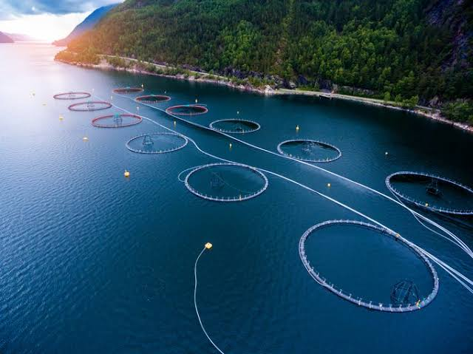

1.1 Significance and Scope of work

The importance of AI in aquaculture technology stems from its capacity to handle industrial difficulties like as disease outbreaks, water quality control, and feed availability. Farmers may use AI to monitor the health and activity of their fish populations in real time, forecast disease outbreaks, and improve feeding regimens by using AI to aquaculture. By improving water quality and reducing the usage of antibiotics and other chemicals, this technique can also assist to lessen environmental problems.

The scope of work in AI in aquaculture technology involves investigating numerous industry applications of AI, such as the use of machine learning algorithms for predictive modelling, picture and audio recognition, and natural language processing. Moreover, research may concentrate on the development of new AI algorithms and technologies that may better suit the demands of the aquaculture sector, as well as solving the constraints and limits of present AI applications. Furthermore, the scope of work may include the development of novel sensors and data gathering systems that can supply the high-quality data required to properly train AI algorithms.

Lastly, the area of work may involve investigating the possible ethical aspects of employing artificial intelligence in aquaculture, such as ensuring that the technology is utilised properly and does not have unexpected repercussions. Generally, the scope of study in AI in aquaculture technology is extensive, spanning a variety of applications and research paths targeted at enhancing the aquaculture industry's sustainability and efficiency.

1.2 Background Information

The utilization of technology in fish farming has been gradually increasing over the past few years, as cultivators strive to enhance production efficiency and diminish adverse effects on the environment. One of the primary difficulties confronting the sector is the outbreak of diseases, which can result in significant economic losses and environmental harm. To tackle this problem, scientists have been investigating the application of AI algorithms for disease anticipation and management. Moreover, image and speech recognition technology has also been put to use in fish farming, enabling cultivators to keep track of the health and behaviour of their fish populations in real-time. This technology can identify peculiar behaviour or physiological changes in fish, indicating potential health problems or environmental stress. To overcome these challenges, researchers and industry stakeholders are exploring novel data collection and management approaches, as well as creating new AI algorithms and technologies that can better cater to the necessities of the fish farming sector.

* 1. Objectives

The Objectives in AI in aquaculture technology are multifaceted and include:

1. Disease prediction and management: Predicting and managing disease outbreaks is one of the key goals of AI in aquaculture technology. Machine learning algorithms can detect possible illness hotspots and enable farmers to take precautionary steps by evaluating environmental factors and fish behaviour.
2. Optimization of feeding regimes: Another goal of AI in aquaculture technology is to optimise feeding regimes, lowering feed requirements while increasing growth and decreasing waste. To find the ideal feeding regime for a specific fish population, machine learning algorithms can assess data on feeding behaviour, fish growth rates, and environmental factors.
3. Water quality management: Artificial intelligence (AI) in aquaculture technology may also be used to monitor and regulate water quality, lowering the risk of environmental harm and enhancing fish health. Machine learning algorithms can assess data on water temperature, oxygen levels, and other environmental factors to detect possible problems and allow farmers to take necessary action.
4. Sustainability and environmental impact: Another goal of AI in aquaculture technology is to increase the industry's sustainability and lessen its environmental effect. AI can assist to develop a more sustainable and ecologically friendly aquaculture business by optimising feeding regimens, decreasing waste, and avoiding the use of antibiotics and other chemicals.
5. Market analysis and consumer preferences: Lastly, AI in aquaculture technology may be used to monitor market trends and customer preferences, allowing producers to better understand and adapt to changing market needs. Machine learning algorithms may assist companies in developing new goods and marketing tactics that better fit the demands of their target market by studying data on customer behaviour.

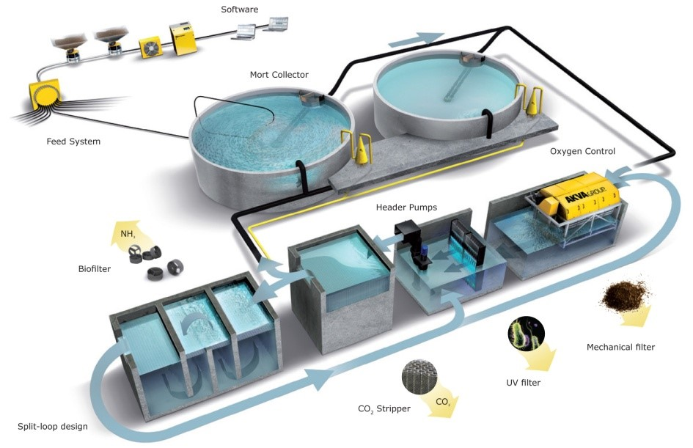

2. Noteworthy Contribution

Although the topic of artificial intelligence in aquaculture technology is still in its early stages, some notable contributions have already been made. Following are some examples of relevant research and literature reviews:

1. Application of Artificial Intelligence(AI) Techniques in aquaculture, A review by W.J.shen and his colleagues (2021):This review article takes an in-depth look at the present level of AI in aquaculture technology. The article addresses the possible uses of artificial intelligence techniques such as machine learning, picture and audio recognition, and natural language processing in the aquaculture business. The authors also discuss the problems and limitations of AI in aquaculture, as well as future research directions.

The relevance of data gathering and analysis in the success of AI applications in aquaculture is emphasised in the paper, as is the necessity for ongoing research and development to increase the accuracy and efficacy of these approaches. The authors also highlight the possible benefits of artificial intelligence (AI) in aquaculture, such as enhanced disease control, increased production efficiency, and decreased environmental impact.

Overall, the study gives useful insights into the current level of AI in aquaculture technology and emphasises the importance of ongoing research and development to fully realise the promise of these approaches in the aquaculture business.

1. M. N. Hossain and colleagues Artificial Intelligence Methods in Aquaculture: An Overview" (2020) is a literature review that offers an overview of the many AI approaches that have been used in aquaculture. The article addresses the possible uses of several approaches, such as machine learning, genetic algorithms, and fuzzy logic, in the aquaculture business. The authors underline the relevance of AI in tackling aquaculture sector difficulties such as disease outbreaks, environmental concerns, and production efficiency. The paper also explores the possible benefits of artificial intelligence in aquaculture, such as enhanced disease management, higher production efficiency, and lower environmental impact. The study emphasises the importance of continuing AI research and development in aquaculture, particularly in the areas of data collecting and analysis. The authors also advise that further multidisciplinary research, such as partnerships between computer scientists, aquaculture researchers, and industry stakeholders, is required to fully realise the promise of AI in aquaculture. Overall, the essay gives an excellent review of the present status of AI in aquaculture, emphasising the potential benefits and problems of these approaches in the aquaculture business. The study also offers future research directions, highlighting the need of ongoing multidisciplinary collaboration and technical improvement in this sector.
2. A Review of Deep Learning in Aquaculture" authored by L. Wang and colleagues (2021): This provides a thorough literature review that concentrates on the use of deep learning methods in the aquaculture field. The paper encompasses various deep learning techniques, including convolutional neural networks (CNNs), recurrent neural networks (RNNs), and deep belief networks (DBNs).The paper gives an outline of the current status of deep learning in aquaculture and discusses the potential applications of these techniques in areas like disease diagnosis and classification, feed management, and water quality monitoring. The review highlights the significance of data pre-processing and feature extraction in the success of deep learning models in aquaculture.

The authors also discuss the limitations of deep learning in aquaculture, such as the requirement for large and diverse datasets and the potential for overfitting. They propose strategies for addressing these challenges, such as transfer learning and the use of ensemble methods. All in all, the paper provides an important overview of the current status of deep learning in aquaculture and emphasizes the potential applications and challenges of these techniques in the industry. The review also suggests areas for future research, underscoring the need for continued development and improvement of deep learning models in aquaculture.

1. "Machine Learning for Aquaculture: A Comprehensive Review" authored by P. Giri and co-authors (2021) presents a comprehensive survey of the utilization of machine learning techniques in the field of aquaculture. The study encompasses a range of machine learning techniques, such as supervised learning, unsupervised learning, and reinforcement learning.

The authors emphasize the potential applications of machine learning in aquaculture, including the diagnosis and classification of diseases, monitoring water quality, and managing feed. The review also discusses the significance of data quality, pre-processing, and feature selection in the triumph of machine learning models in aquaculture. The article highlights the necessity for continued research and development in the domain of machine learning in aquaculture, particularly in the areas of data standardization and integration, feature engineering, and model optimization. The authors also underline the importance of interdisciplinary collaboration between computer scientists, aquaculture researchers, and industry stakeholders. All in all, the article furnishes a valuable synopsis of the present state of machine learning in aquaculture and underscores the potential applications and challenges of these techniques in the industry. The review also proposes areas for future research, highlighting the necessity for the perpetual development and improvement of machine learning models in aquaculture.

3. Proposed Methodology

The proposed ARP employs entities related to aquaculture farming, such as open-source data pertaining to aquaculture cloud data centre, mobility model for node deployment, underwater sensor unit to measure water parameters, data acquisition, and ETL (Extract, Transform, Load) methods. These organisations aid in site selection and give information on the various varieties of fish that may be grown. Figure 1 depicts the ARP model architecture of the proposed work for an aquaculture monitoring station. Underwater sensors assess water factors such as temperature, dissolved oxygen, pH, salinity, and turbidity, which are necessary for aquaculture. The sensor nodes communicate wirelessly to continually deliver monitored data to the cloud data centre.

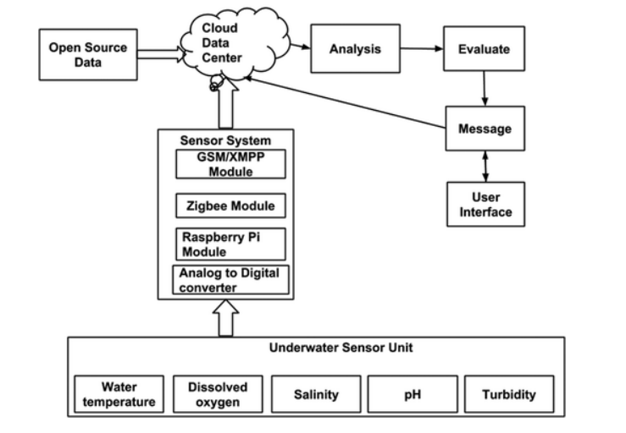

Figure 1. ARP System architecture for monitoring aquaculture site.

3.1 Mobility model of surface floating node

The location of the wireless sensor node is critical in sensing water parameters for aquaculture monitoring. The mobility model for sensor system design (Figure 2) is presented for aquaculture to discover particular places with water parameter fluctuation in the river, taking into account water currents. Water factors such as temperature, dissolved oxygen, pH, salinity, and turbidity are detected using sensors coupled to probes that are deployed to float at precise depths. The water parameters measured by the sensor system are transferred to the cloud data centre over the XMPP protocol, which records the data in a MySQL database using web services written in Hypertext Pre-processor. (PHP).

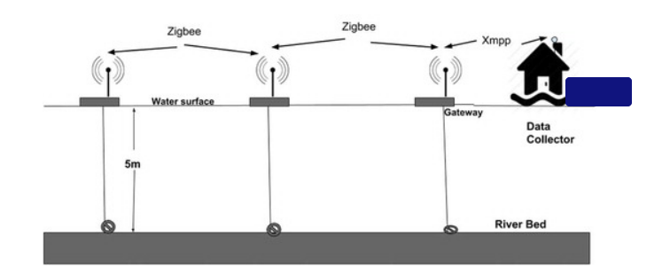

Figure 2. Sensor system architecture for real time aquaculture monitoring.

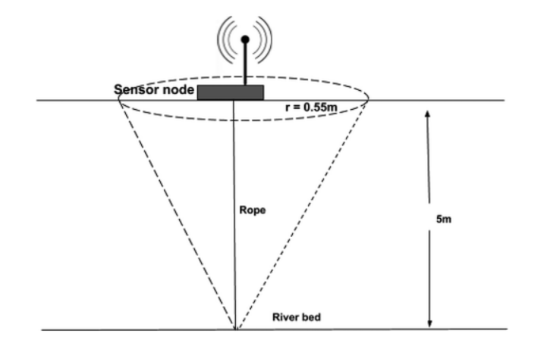

Figure 3. Movement of sensor nodes floating at water surface anchored to riverbed.

Figure 4 depicts the various node placements that predict mobility behaviours to obtain high accuracy with little overhead for observed water parameters. It is sufficient to achieve the mobility characteristic of the floating sensor network by finding the floating locations of the sensor. This aids in node position planning in order to select particular locations in the river where sensor nodes can be installed and water parameters may be monitored in real time in aquaculture design and planning.

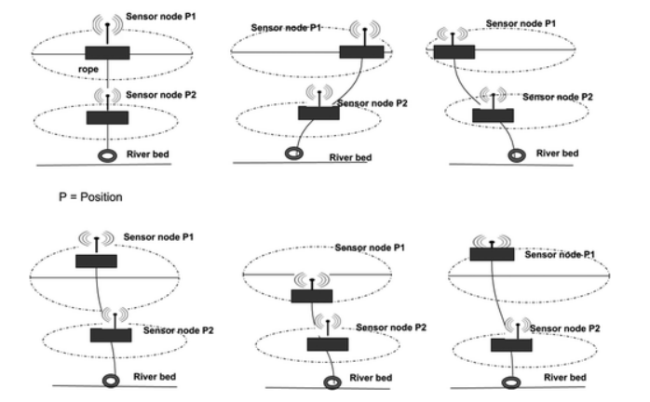

Figure 4. Sensor node position due to water currents.

4.Aquaculture resource planning model

This section uses resources defined in Section [3](https://www.tandfonline.com/doi/full/10.1080/23311916.2018.1542576#S0004) for developing an aquaculture monitoring system for river site selection, the methodology and implementation is carried out.

4.1. Sensor system design

The raspberry pi B model board, communication module, power supply board, 8 channel 10-bit ADC (MCP3008), and sensor modules compose the total sensor system. Figure 5 depicts the sensor system hardware block diagram. Temperature, dissolved oxygen, pH, salinity, and turbidity are all measured by the sensor unit. The sensor units are linked to the ADC unit, and the corresponding digital data of the measured sensor values is interfaced to the Raspberry Pi board's GPIO pins. Using GSM/XMPP connection modules, the raspberry pi transfers the measured data to a cloud data centre.

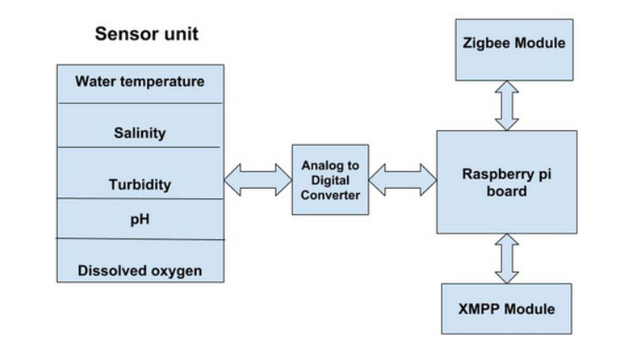

Figure 5. A block diagram of the sensor system hardware.

The Raspberry Pi is loaded with a custom software programme that collects data from the sensor device. The raspberry pi detects variations in water parameters in relation to threshold levels. The threshold values are set to precise levels that are beneficial to fish life. If the measured value varies in relation to the threshold, an alarm signal is generated. To save battery voltage, the sensor device enters sleep mode after transmitting. The sleep mode time period may be adjusted to meet your needs. A flow chart for sensor system functioning is shown in Figure 6. The sensor system's primary role is to measure the water parameters of river locations suitable for aquaculture. Temperature, dissolved oxygen, pH, salinity, and turbidity are all measured by the sensor system. The measured water parameter is compared to the sensor's threshold value, which is set to the specific limit necessary for aquaculture.

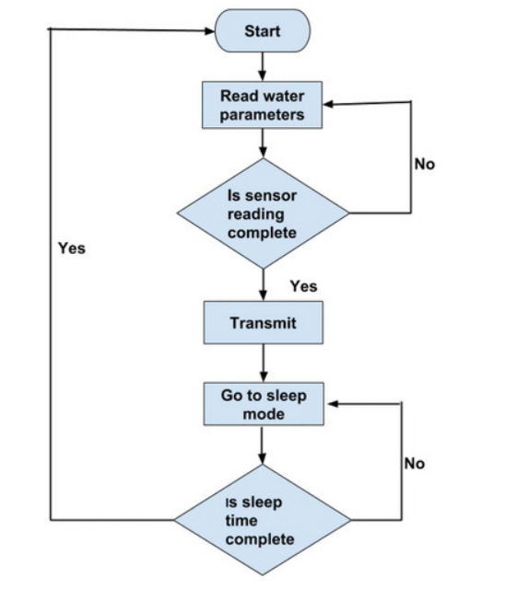

Figure 6. A flowchart describing the working of the sensor system.

4.2 Cloud Architecture

The accuracy of gathering data is achieved using wireless sensor network (WSN) and promotes to apply new sensing strategies. Underwater wireless sensor system is connected to the gateway to collect the sensed water parameters data. The collected data is loaded to database server, analysed, and made available to the users accessed to the aquaculture web application.

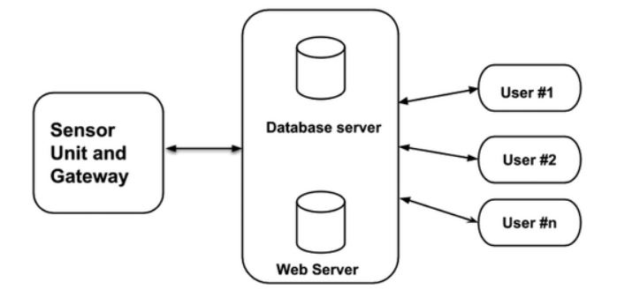

Figure 7. Sensor cloud architecture for WSN gateway.

5 Result Analysis

The results of clustering which specifies different fish species that can be cultured for a specific river. Clustering is used to analyse real-time data based on fish farmed in these three rivers. Here, fish such as sea bass, red snapper, mullet, and pearl spot can be cultured throughout the year, where the information pertaining to this river site with standard water parameters, and seed availability information will be updated and accessible as an article for farmers.

5.1 Aqua ward Application

Water parameter option is exclusive for a particular river site, where the users can select the river. The fish type’s option provides the complete information about different fish, with the seed availability for a particular fish. The data analysis option provides information about water parameters variation with respect to seasons and time at a particular river site. The proposed application enables farmer groups, aquaculture businesses, government, and non-government agencies working with smallholder farmers make informed decisions, improve overall operational efficiency, and traceability.

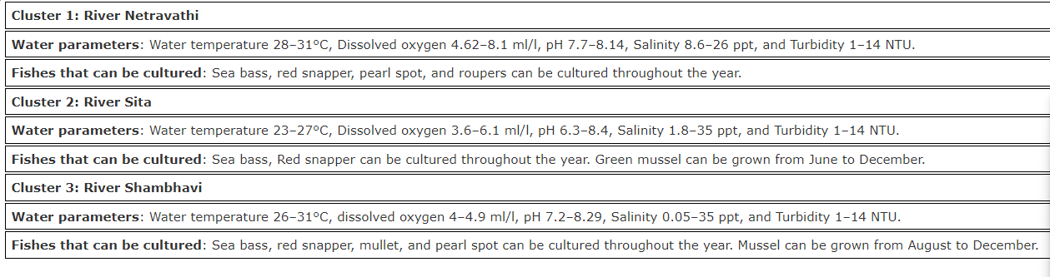

Table 1: Showing Clustering results of three rivers with respect to fish species.

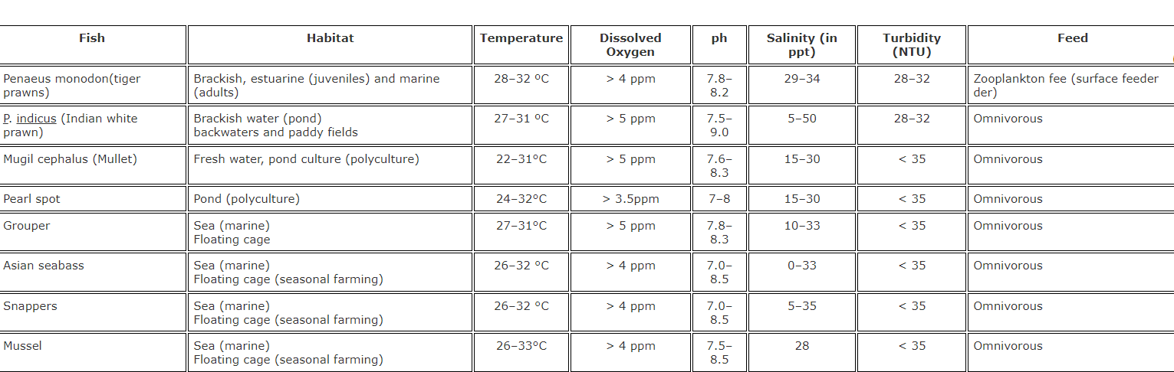

Table 2: Showing Standard water parameter required for specific fish species, habitat and feeding habits where 1 mg/L= 1ppm.

6. Conclusion

To sum up, AI technology has demonstrated its efficacy in the aquaculture sector, enabling farmers to enhance their efficiency and sustainability while cutting down on expenses and environmental harm. From water quality monitoring to feed optimization and disease outbreak prediction, AI systems have displayed their potential to advance production and guarantee the well-being of aquatic life. For instance, AI-powered systems can observe the growth and behaviour of fish, detect early signs of disease or stress, and adjust feeding rates accordingly, which not only benefits the health and welfare of the animals but also increases their growth rates and overall productivity. Additionally, AI can help to enhance the efficiency of energy and water use, which are significant factors in aquaculture production. By tracking the origin and history of each batch of fish, farmers can ensure that their products meet quality and safety standards, and provide consumers with transparency and assurance. Despite the numerous benefits of AI in aquaculture, there are also some challenges and limitations to its implementation. Additionally, AI systems require a significant amount of technical expertise and data analysis skills, which may not be readily available in some regions. Moreover, it is crucial to engage with local communities and stakeholders to ensure that the adoption of AI technology is culturally appropriate and socially responsible. However, it is essential to address the challenges and limitations of AI implementation, such as cost, technical expertise, and social implications, to ensure that the benefits of this technology are accessible to all and used in a responsible manner.

7.Refrence

1. Design and implementation of aquaculture resource planning using underwater sensor wireless network by Shreema Shetty , Radhika M Pai & Manohara (2018).
2. Artificial Intelligence in Aquaculture current status and future prospects by Nils Martin and Nikolai Winge (2021).
3. Artificial Intelligence and Robotics for sustainable aquaculture by Pradeep Pillai, Mahdi Khodaparast and Mohsen Jahan Shahi(2020).
4. A review on artificial intelligence and machine learning techniques in marine and aquaculture ecosystems by Seyed Saeid Mohtasebi, Rahul A khan and Mohammad Hasan (2022).
5. A review of the application of artificial intelligence in aquaculture by Feng Gao, Jinxin Liu and Hongshan Liu.

8. Appendix(CODE)

    import java.util.ArrayList;

public class AIinAquaculture {

// Define variables for the AI model

private double temperatureThreshold = 25.0;

private double pHThreshold = 7.5;

private double oxygenThreshold = 5.0;

private double ammoniaThreshold = 0.5;

private double nitrateThreshold = 50.0;

// Define the main method

public static void main(String[] args) {

// Initialize the AI model

AIinAquaculture ai = new AIinAquaculture();

// Create a list of water quality measurements

ArrayList<WaterQualityMeasurement> measurements = new ArrayList<>();

measurements.add(ai.new WaterQualityMeasurement(24.0, 7.2, 4.0, 0.3, 40.0));

measurements.add(ai.new WaterQualityMeasurement(26.0, 7.4, 5.0, 0.4, 55.0));

measurements.add(ai.new WaterQualityMeasurement(25.5, 7.1, 4.5, 0.2, 45.0));

// Use the AI model to analyze the water quality measurements

for (WaterQualityMeasurement measurement : measurements) {

ai.analyzeWaterQuality(measurement);

}

}

// Define a method to analyze water quality

public void analyzeWaterQuality(WaterQualityMeasurement measurement) {

// Check if the temperature is above the threshold

if (measurement.getTemperature() > temperatureThreshold) {

System.out.println("Temperature is too high!");

}

// Check if the pH is above the threshold

if (measurement.getPH() > pHThreshold) {

System.out.println("pH is too high!");

}

// Check if the oxygen level is below the threshold

if (measurement.getOxygen() < oxygenThreshold) {

System.out.println("Oxygen level is too low!");

}

// Check if the ammonia level is above the threshold

if (measurement.getAmmonia() > ammoniaThreshold) {

System.out.println("Ammonia level is too high!");

}

// Check if the nitrate level is above the threshold

if (measurement.getNitrate() > nitrateThreshold) {

System.out.println("Nitrate level is too high!");

}

}

// Define a class to represent a water quality measurement

private class WaterQualityMeasurement {

private double temperature;

private double pH;

private double oxygen;

private double ammonia;

private double nitrate;

public WaterQualityMeasurement(double temperature, double pH, double oxygen, double ammonia, double nitrate) {

this.temperature = temperature;

this.pH = pH;

this.oxygen = oxygen;

this.ammonia = ammonia;

this.nitrate = nitrate;

}

public double getTemperature() {

return temperature;

}

public double getPH() {

return pH;

}

public double getOxygen() {

return oxygen;

}

public double getAmmonia() {

return ammonia;

}

public double getNitrate() {

return nitrate;

}

}

}

9. Output

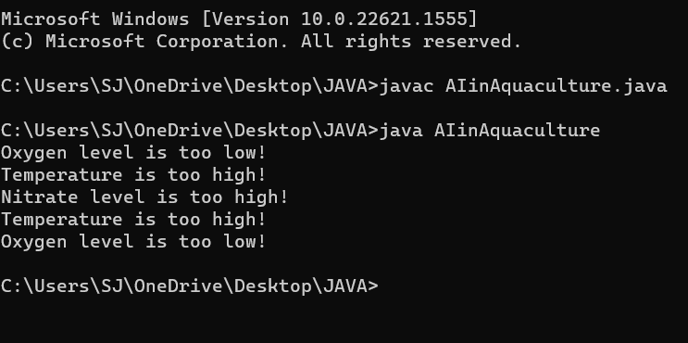

**Thank You!**